

**IMC Ramkrishna Bajaj National Quality Award Trust  
Registration Form**

|  |
| --- |
| Understanding the IMC RBNQ Award Criteria  Date: 24-25 April 2019  Time: 10.00am to 5.30pm  Duration: 2 Day  Venue: Walchand Hirachand Hall, IMC Mumbai  *\*Complimentary Workshop*  *Yes* |

|  |  |
| --- | --- |
| Details: | |
| 1. Organization Name:  _________________________________________ | |
| 2. Address:  ________________________________________  ________________________________________  ________________________________________  _______________________________________ | |
| 3. Participants: |  |
| Name:____________________________  Cell:__________________________ | Designation: ______________________________  Email: ___________________________________ |
|  |  |
| Name:___________________________  Cell:__________________________ | Designation: ______________________________  Email: ___________________________________ |

**Contact: Ms Maya Desai, Director**

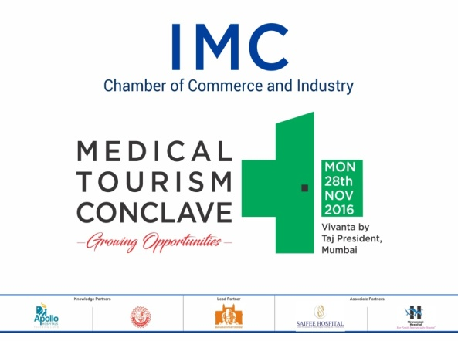 **IMC Ramkrishna Bajaj National Quality Award Trust**

IMC Chamber of Commerce & Industry, IMC Marg, Churchgate, Mumbai-20

Tel: (022) 22025438/ 71226689

E: mayad@imcrbnqa.com; [excellence@imcrbnqa.com](mailto:excellence@imcrbnqa.com)

W: [www.imcrbnqa.com](http://www.imcrbnqa.com)